Project Name

LIT :fire: - learn imagine think

## About the Project

// here goes a short description

Tired of Switching courses??

OR Still Struck at Reading Docs??

NOW, NO more IF’s And BUT’s

WE, at LIT have your back

LIT provides you the most organised form of learning and that too absolutely FREE!!!

SO head on to your learning track and Start exploring what we have stored in for YOU.

LIT is a platform that not only teaches you, but helps visualise the concepts that make you capable to think on real life problems. We understand how it feels getting lost in a web full of scattered information. At LIT, we believe in learning that is organised and catered to the needs of every student.

So here we are and we have organised for you all the useful resources at your single click. Not only this we have provided online IDE’s on our website for hands on practise.

We have Front-end, Back-end, Machine Learning and Cloud Computing tracks to meet your demands. Join our newsletter to receive updates for upcoming courses and latest technology news.

## Technologies used

// list of technologies, frameworks, libraries, open-source code with links

Html, css, bootstrap, javascript, php.

## Steps for installation

// step by step procedure with prerequisites for installation of the product

on a local environment

Steps of cloning a github file :

Step-1: On GitHub, navigate to the main page of the repository.

Step-2: Above the list of files, click Code.

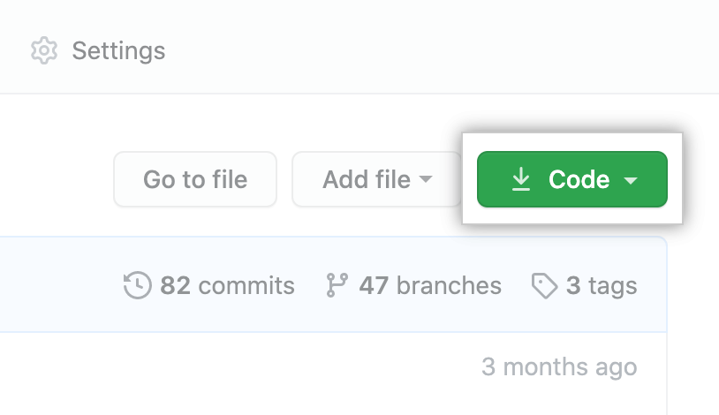

Step-4: To clone the repository using HTTPS, under "Clone with HTTPS", click . To clone the repository using an SSH key, including a certificate issued by your organization's SSH certificate authority, click Use SSH, then click . To clone a repository using GitHub CLI, click Use GitHub CLI, then click .

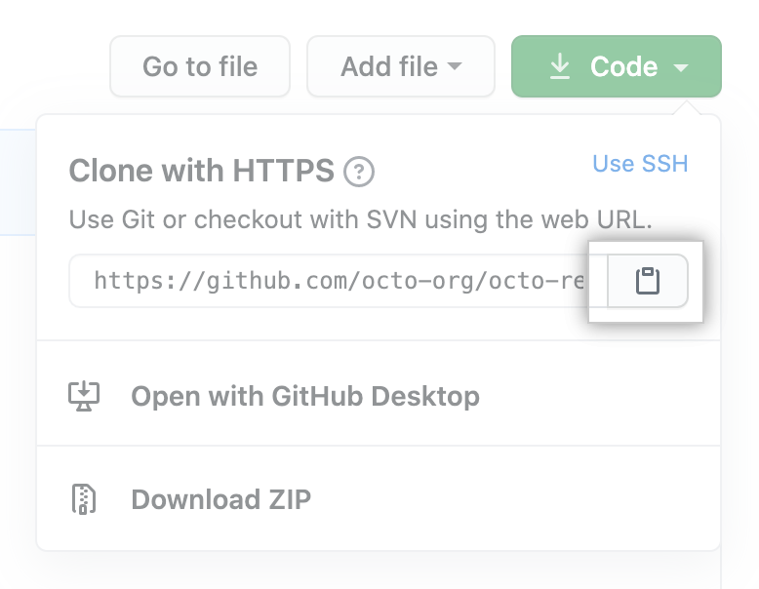

Step-4:Open Git Bash.

Step-5:Change the current working directory to the location where you want the cloned directory.

Step-6:Type git clone, and then paste the URL you copied earlier.

$ git clone https://github.com/*YOUR-USERNAME*/*YOUR-REPOSITORY*

Step-7:Press Enter to create your local clone.

$ git clone https://github.com/*YOUR-USERNAME*/*YOUR-REPOSITORY*

> Cloning into `Spoon-Knife`...

> remote: Counting objects: 10, done.

> remote: Compressing objects: 100% (8/8), done.

> remove: Total 10 (delta 1), reused 10 (delta 1)

> Unpacking objects: 100% (10/10), done.

## App/Web link if hosted (recommended but optional)

## Video Demo (Mandatory)

// link to a video demo. you can upload videos on google drive. Make sure that

the video is accessible for anyone with the link.

<https://youtu.be/3zZyARUkokI>

## Screenshots (Mandatory)

// Screenshots regarding your project. you can provide a drive folder link with

screenshots or upload it on github itself.



